SQL Profile enable examples

After initial login to OEM as oracle dba. Select database target. Identify SQL ID and before running Tunning Advisor you will need Log to database target in OEM under your A/N oracle account (or system database account)

Go to ORACLEDBA click Log Out

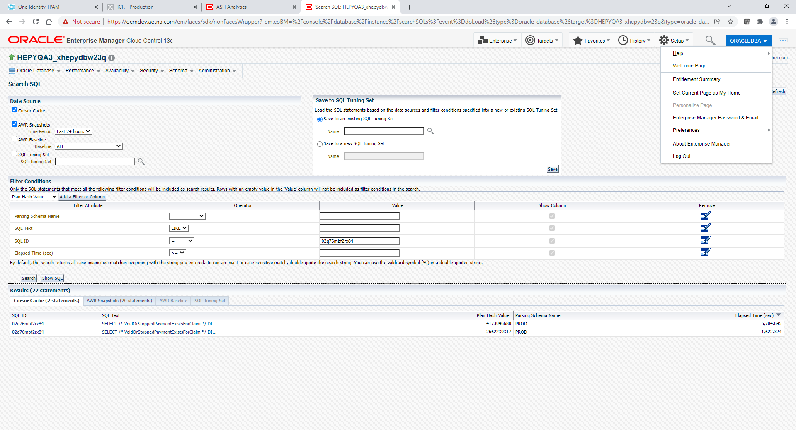

Select Display login page after logout checkbox. Click Logout button.

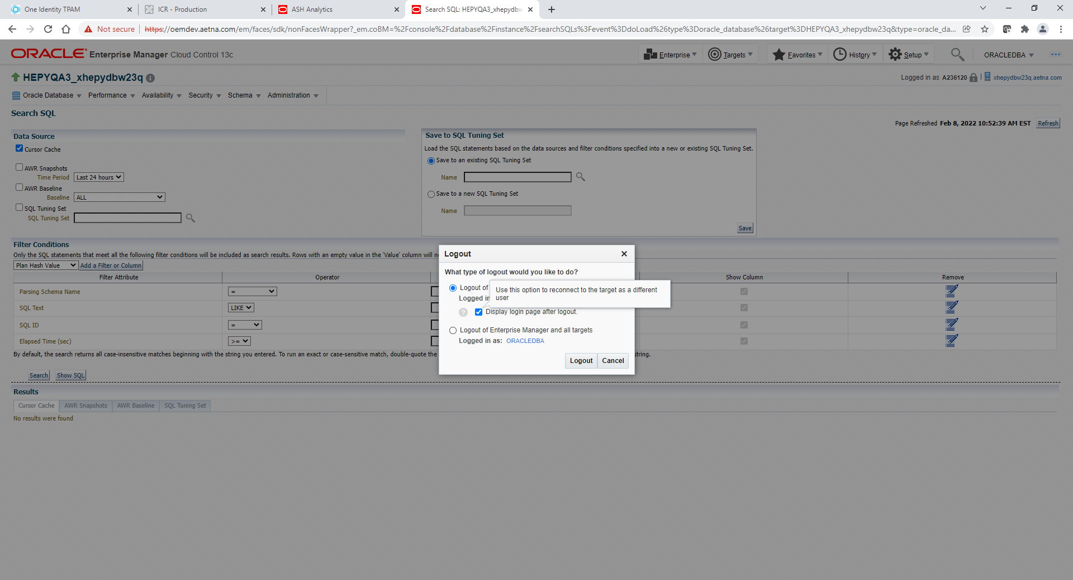

Select New and type your Oracle Database AID and P. Click Login.

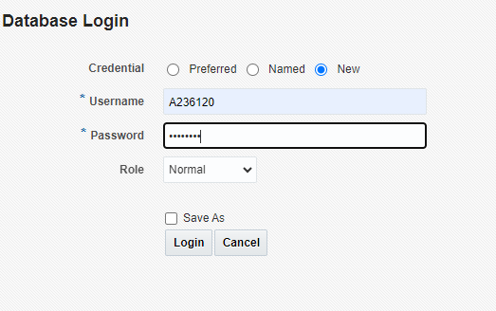

**Example #1**

If Tuning Advisor recommends only parallel SQL Profile**. Do not attempt to enable**. **Do not recommend.**

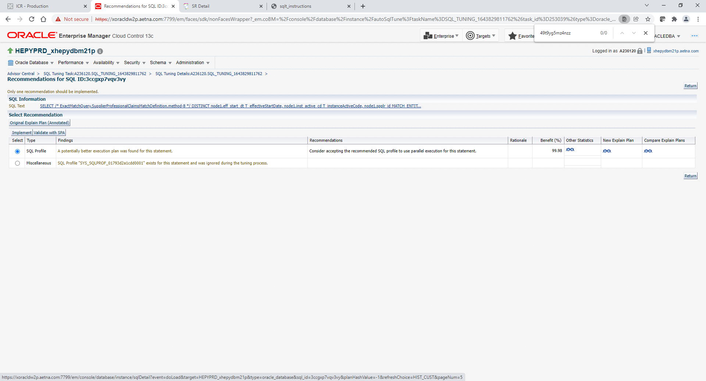

**Example #2**

If Tuning Advisor recommends both parallel SQL Profile and Regular SQL Profile

**Do not attempt to enable Regular SQL Profile from OEM. Even if you choose Regular SQL Profile option to enable it will end up enabling other parallel SQL Profile.**

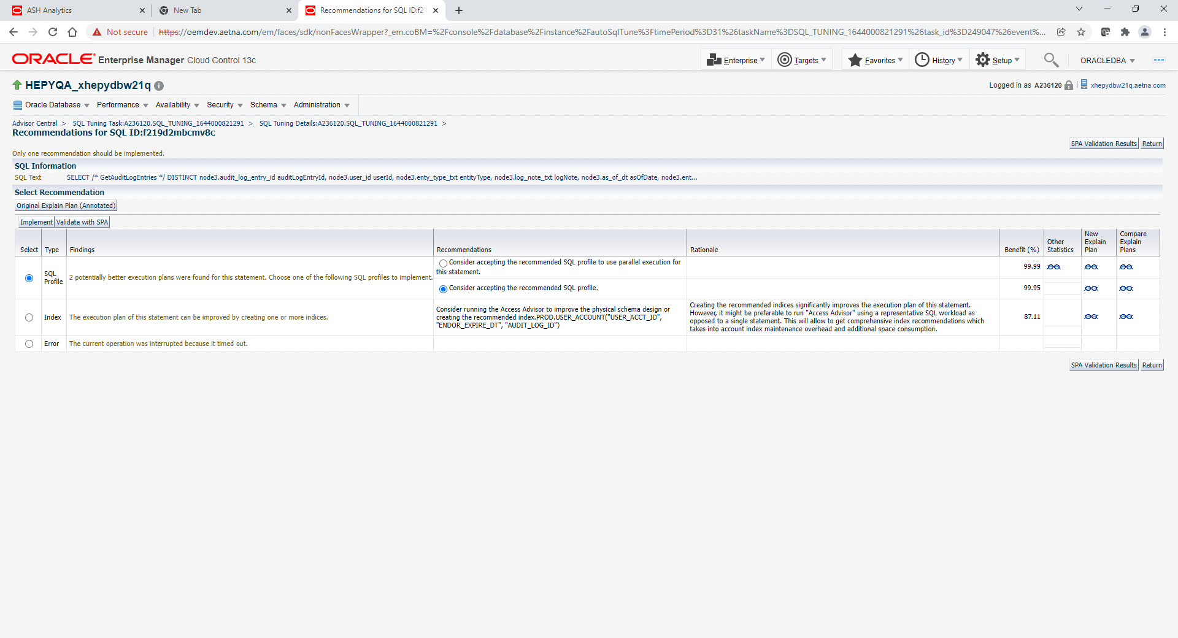

**Compare the SQL plans as opposed to just looking at the percentage and enabling**

**Instead do this manually from sqlplus session. Specify appropriate task_name and task_owner (should be DB account under which Tuning Advisor was executed)**

**sqlplus / as sysdba**

**execute dbms_sqltune.accept_sql_profile(task_name =>'SQL_TUNING_xxxx', task_owner => 'you’re A/N ID', replace =>TRUE, force_match => TRUE);**

**Example #2**

If Tuning Advisor recommends Regular SQL Profile

**Compare the SQL plans as opposed to just looking at the percentage and enabling**

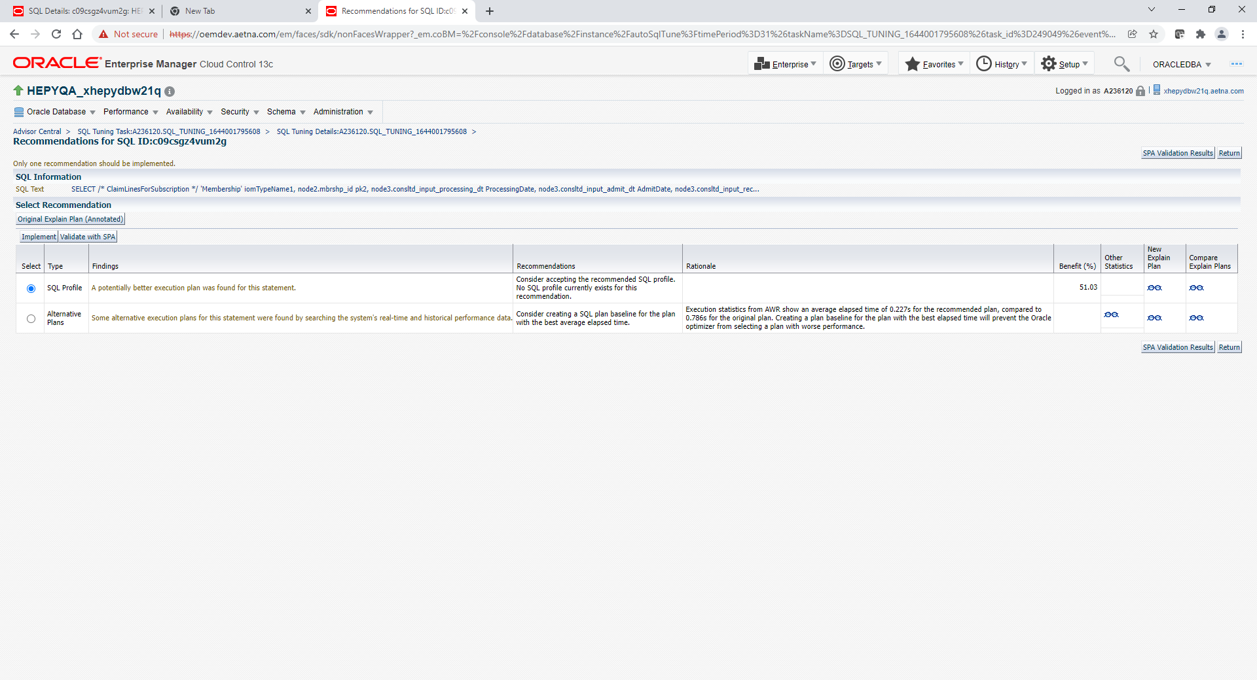

Click implement button

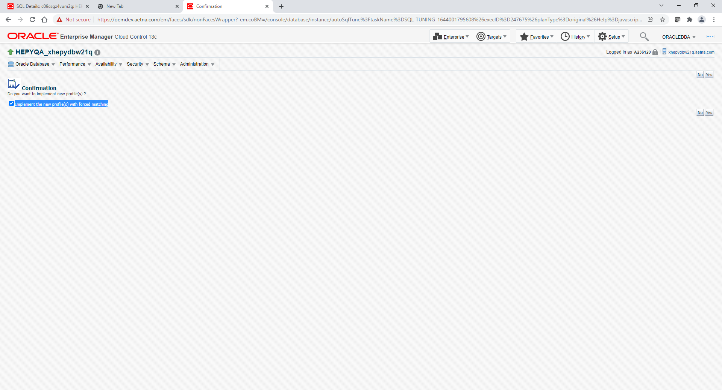

Implement the new profile(s) with forced matching – make it checked and click yes